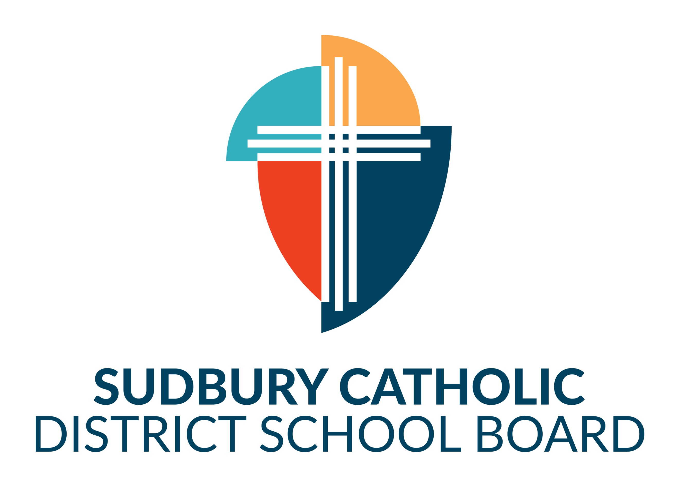
Attendance Awareness Month

Poster Contest 2026-2027

Name: ________________________ Grade: ________
School: _________________________________________
Your Presence Matters !
Attendance Awareness Campaign
Poster Contest 2026-2026
Sudbury Catholic Schools Attendance Counsellors are sponsoring a poster contest to engage students in kindergarten through grade 12 in promoting the importance of regular school attendance!
Students are invited to create and submit for the 2026-2027Attendance Awareness Month poster contest in October. This is an opportunity for students to share their views on why school attendance is important. The winning posters will be reproduced with the artist’s name on the poster and distributed throughout the schools for the academic school year.
There are four categories for submission: (FDK Year 1- Grade 3) (Grades 4 – 6) (Grades 7 & 8) (Grades 9 – 12)
INSTRUCTIONS:
- Entries should illustrate a message that communicates the importance of school attendance. It must include the following statement “Your Presence Matters” Students can illustrate what inspires and motivates them to attend and “Your Presence Matters” at school every day.
- Only one entry per student.
- Design can include an original drawing or computer-generated design (300 dpi resolution) but must be created by the student. We encourage use of original work.
- Posters must be on the 8 1/2 X 14 inches’ template provided. Please no gluing of additional paper or altering of original template.
- Poster design, all photographs, drawings, and/or graphics used on the poster design must be the student’s own original work.
- Print the artist’s name in the lower right-hand corner on the back of art work.
- All entries become the property of Sudbury Catholic Schools.
ATTENDANCE PRIZES (Elementary and Secondary)
$100 Gift Certificate for First Place (First place will also have their poster reproduced and distributed across all schools for the 2026-2027 academic school year.
$50 Gift Certificate for Second Place
$25 Gift Certificate for Third Place

SUBMISSION DEADLINE: November 1st, 2026 by 3:00pm Send Entries to: Amanda Lanthier or Brad Pharand at 165A
D’Youville St.

The principal or vice principal will select 3 overall best submissions/drawings from each of the following grade categories:
- Grades FDK Year 1- Grade 3
- Grades 4 – 6
- Grades 7 & 8
- Grades 9 - 12
JUDGING AND WINNER NOTIFICATION:
The panel of judges will consist of two school board employees, a community member, parent counsel representative and a student representative. A winner will be selected from both elementary and secondary. The winners will be notified in person by the attendance counsellors on November 12th, 2026 Parents of the students will also be contacted by telephone.
#scdsbEveryDay

